Perfect Flowers

What is required for perfect flowers?

A perfect flower must contain both the male reproductive structures (stamen- anther and filament) and female reproductive structures (pistil- stigma, style, and ovary)

Circle the names of the female structures. Underline the names of the male structures.

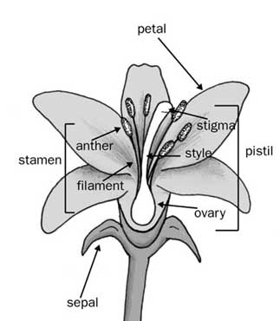

Imperfect Flowers

What makes a flower imperfect?

Imperfect flowers contain either the male portion OR the female portion of the flower, but not both.

Label missing plant structures, and label male and female flowers.

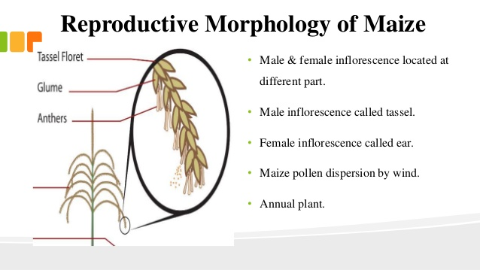

Tassel

Male Flower

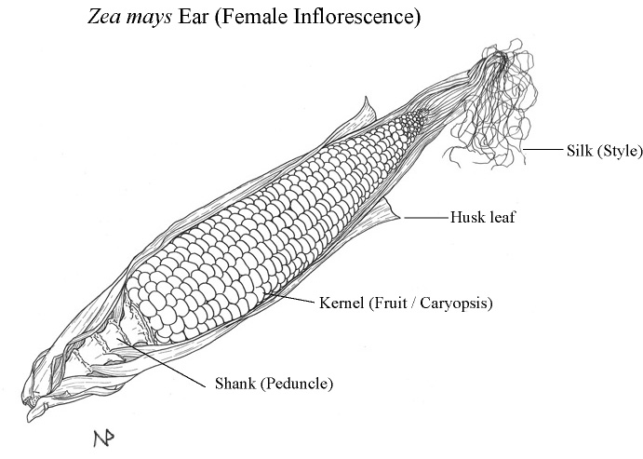

Female Flower

Complete vs. Incomplete Flowers

What four structures are necessary for a complete flower?

Complete flowers contain four flower parts: petals, sepals, stamen, and pistil.

Circle necessary structures in the top illustration. What is the missing structure in the bottom illustration?

The bottom illustration is missing sepals.

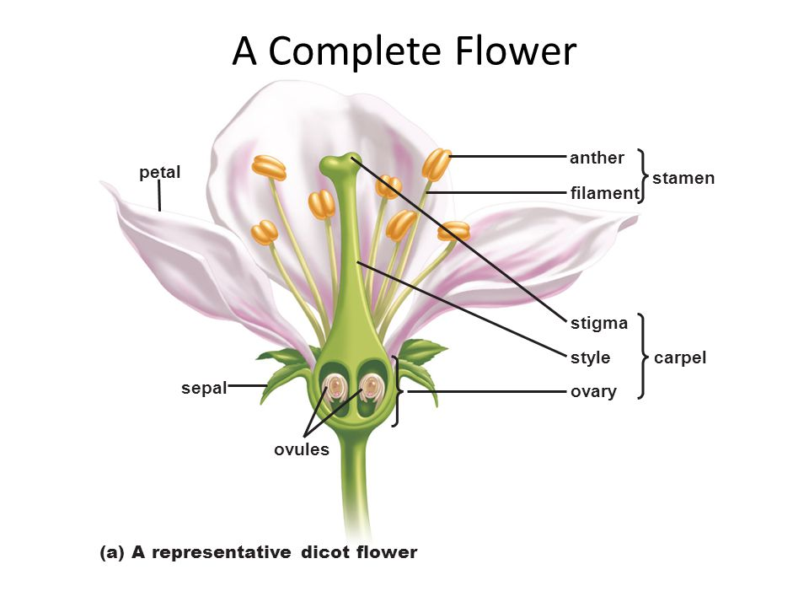

**pistil**

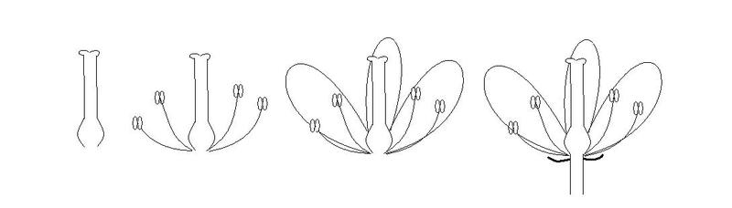

Label all four photos. On the top, write either “perfect” or “imperfect.” Underneath, label either “complete” or “incomplete.”

In the space below, take notes on why this is, or draw additional diagrams.

4

3

1



2

1. Imperfect, incomplete
   1. The pistil is the only reproductive structure pictured. For a flower to be considered perfect it must contain both the male (stamen) and female (pistil) reproductive structures. It is incomplete because the flower is missing the petals, sepals, and stamen.
2. Perfect, incomplete
   1. It is perfect because the flower contains both male (stamen) and female (pistil) reproductive structures. It is incomplete because the flower is missing the petals and sepals.
3. Perfect, incomplete
   1. It is perfect because the flower contains both male (stamen) and female (pistil) reproductive structures. It is incomplete because the flower is missing the sepals.
4. Perfect, complete
   1. It is perfect because the flower contains both male (stamen) and female (pistil) reproductive structures. It is complete because it has all four flower parts: petals, sepals, stamen, and pistil.